**Assignment #1 (AWS)**

**Group member Name:**

**P19-1652 Hifza Majeed  
 P19-1664 Noman  
 P19-1672 Ahmad**

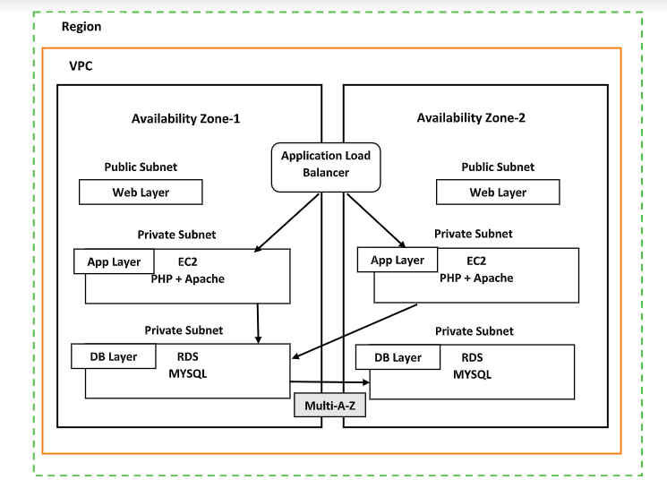

**Step 1: Create a VPC:**

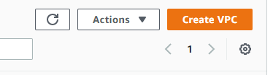

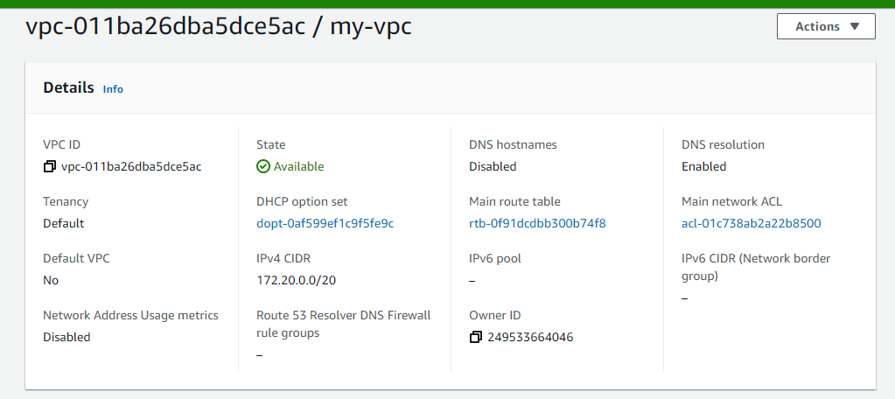

**Step 2: Create Subnet:**

**1. Create 3 public web subnets**

**2. create 3 private app subnets**

**3.create 3 private DB subnet**

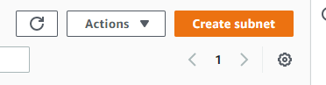

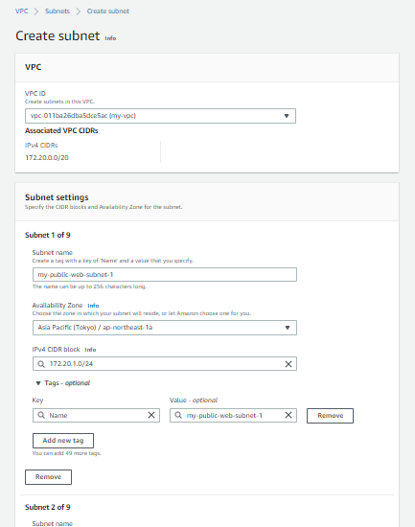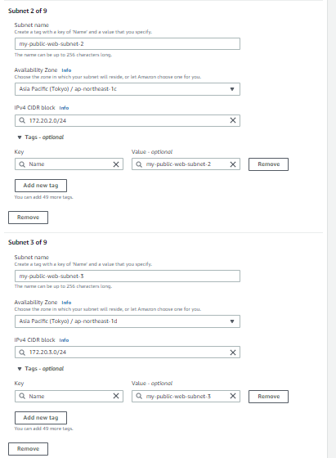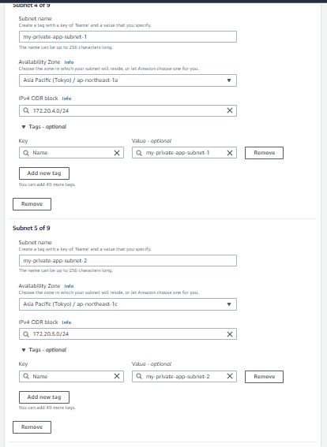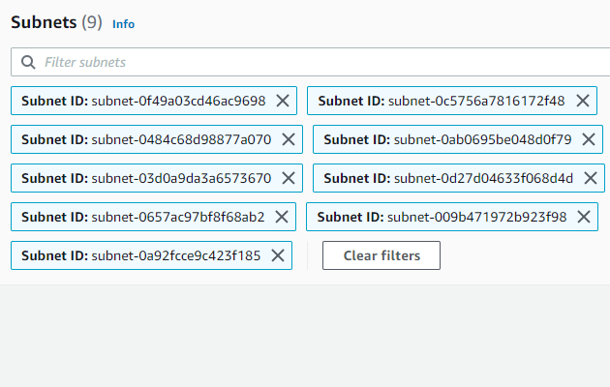

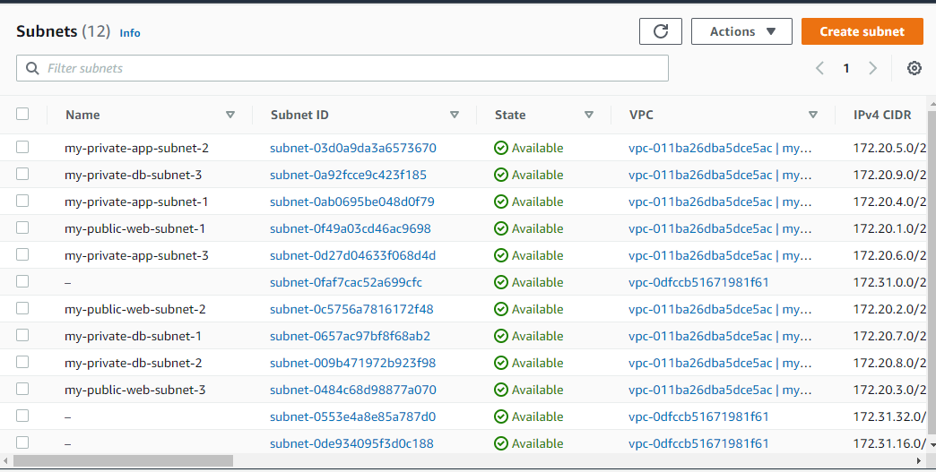

**Step 3: Create a routing table**

1. **Create public web route table**
2. **Create a private app route table**
3. **Create private DB route table**

**After creating the routing table now to associate with the related subnet:**

**Public web router associated with public web subnet:**

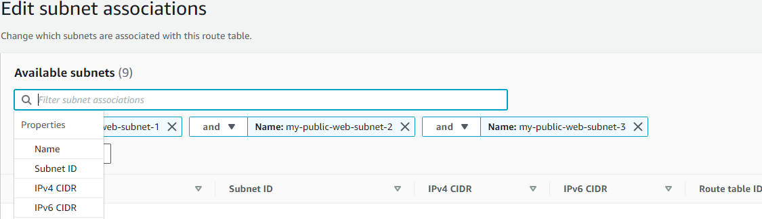

Private app router associated with Private app subnet:

**Private db router associated with Private db subnet:**

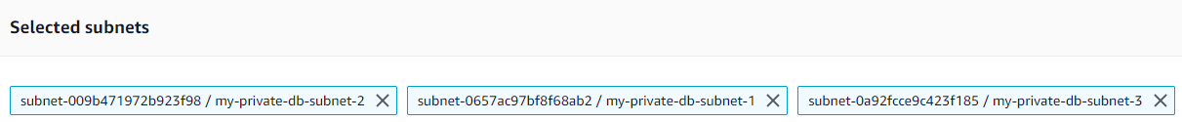

**Step 4: Create Internet gateway:**

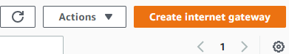

**After Creating then attached to VPC:**

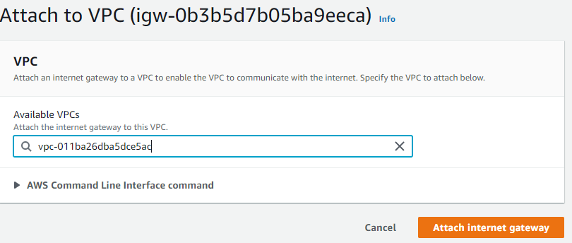

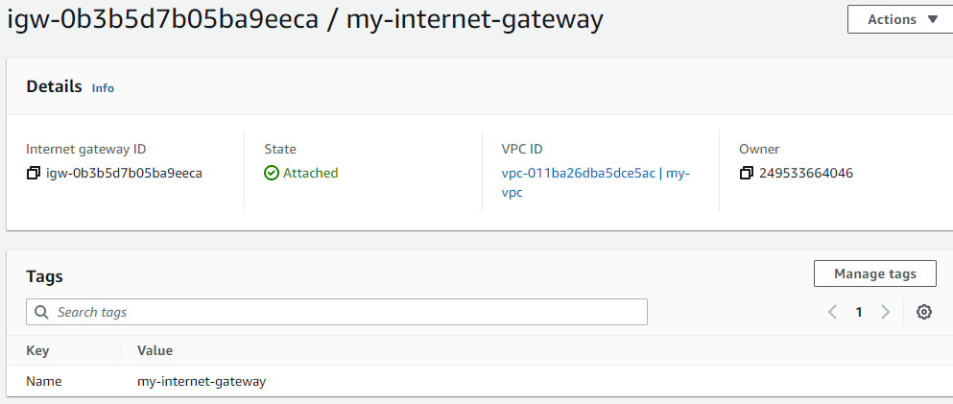

**Step 5: Create NAT gateway:**

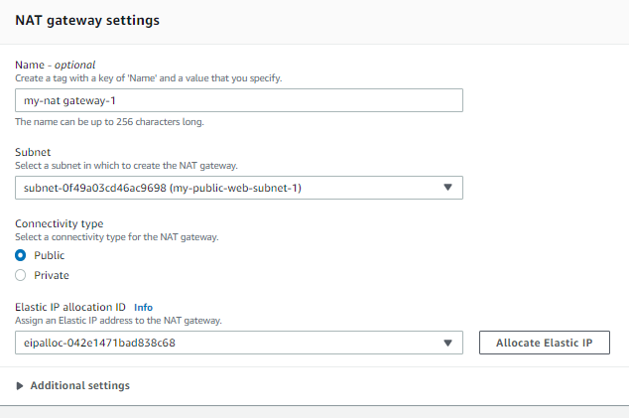

**Connect the internet gateway with bublic router:**

**Connect the NAT gateway with the private app router:**

**Connect the NAT gateway with a Private DB router:**

**Step 6: Create Instances:**

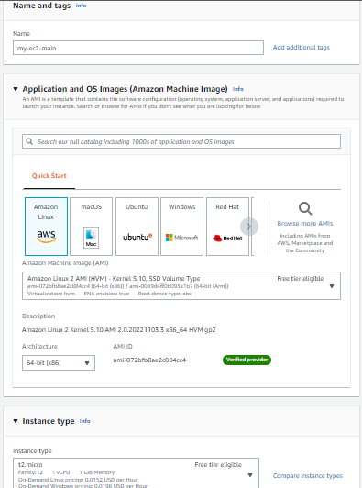

**Create 3 instances:**

**Step 7: Connect EC2 with the local machine(ubuntu)**

**Connect public EC2 with Private EC2:**

**Connect public EC2 with another Private EC2:**

**Step 8: Commands for app server php installment**

1. sudo yum update -y
2. sudo amazon-linux-extras install -y lamp-mariadb10.2 -php7.2 php7.2
3. sudo yum install -y httpd mariadb-server

Stating services

1. sudo systemctl start httpd
2. sudo systemctl enable httpd
3. curl <http://localhost>

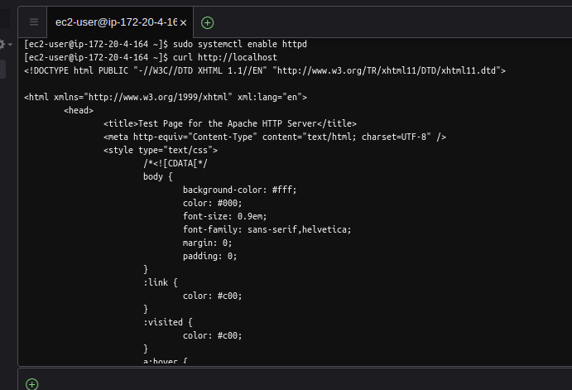

**Step 9: Giving permission**

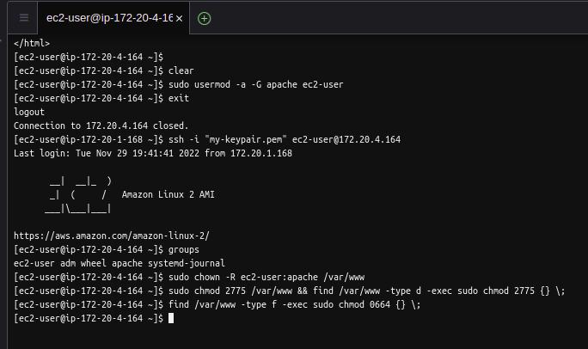

**Step 10: Install PHP on my admin**

**Steps**

1. sudo yum install php-mbstring php-xml -y
2. sudo systemctl restart httpd
3. sudo systemctl restart php-fpm
4. cd /var/www/html
5. wget <https://www.phpmyadmin.net/downloads/phpMyAdmin-latest-all-languages.tar.gz>
6. mkdir phpMyAdmin && tar -xvzf phpMyAdmin-latest-all-languages.tar.gz -C phpMyAdmin --strip-components 1
7. rm phpMyAdmin-latest-all-languages.tar.gz
8. sudo systemctl start MariaDB

**Step 11: Load Balancers**

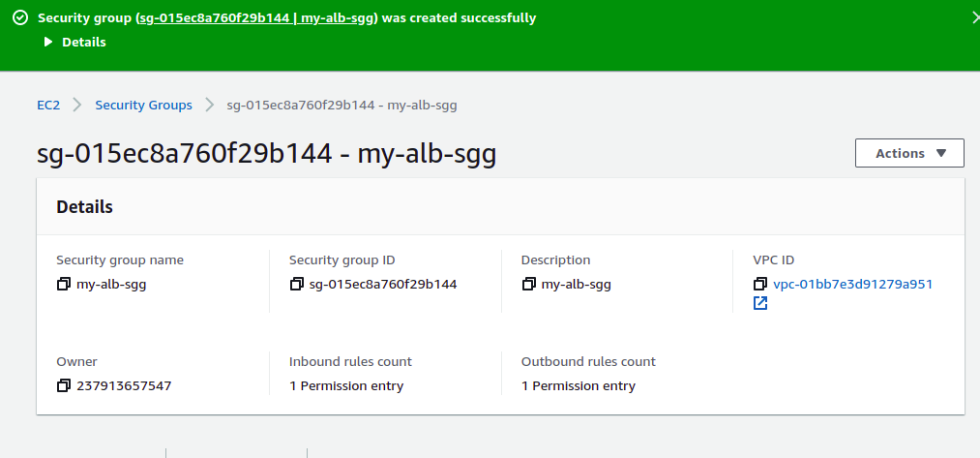

**Step 12:**

**Editing security groups of instances**

**Inbound changes**

**Checking the health state of target groups**

**Copy the DNS NAME of the load balancer and check to work**

**NOW DATA BASE**

**CREATE SUBNETS**

**Creating database**

**Db security group inbound rules**

**File local host to DB**

**PHP my admin**

